HDOC DAY-6 REPORT
Question 1: Radius, Arc Length and Perimeter of a Quadrant
Problem Statement:
Write a C program to find the radius, arc length, and perimeter of a quadrant when its area is given.
Input:
Area of the quadrant (A)
Output:
Radius (r), Arc Length (L), and Perimeter (P)
Formula:
Radius: r = √(4A/π)
Arc Length: L = πr/2
Perimeter: P = 2r + L
Test case | Input (Area) | Expected Output | Actual Output | Result  (Pass/Fail)
1 | 78.54 | r =10 , L = 15.17 , P = 35.71 | r = 10, L = 15.71, P = 35.71 | Pass
2 | 314.16 | r =20 , L = 31.42 , P = 71.42 | r = 20, L = 31.42, P = 71.42 | Pass
3 | 19.635 | r = 5 , L = 7.85 , P = 17.85 | r = 5, L = 7.85, P = 17.85 | Pass

Algorithm:
- Start the program.
- Enter the area of the quadrant (A).
- Calculate the radius using the formula r = √(4A/π).
- Calculate the arc length using the formula L = πr/2.
- Calculate the perimeter using the formula P = 2r + L.
- Display the radius, arc length, and perimeter.
- Stop the program.

#include <stdio.h>
#include <math.h>

int main()
{
float area, radius, arc_length, perimeter;
float pi = 3.14159;

printf("Enter area of quadrant: ");
scanf("%f", &area);

radius = sqrt((4 * area) / pi);
arc_length = (pi * radius) / 2;
perimeter = 2 * radius + arc_length;

printf("Radius = %.2f\n", radius);
printf("Arc Length = %.2f\n", arc_length);
printf("Perimeter = %.2f\n", perimeter);

return 0;
}
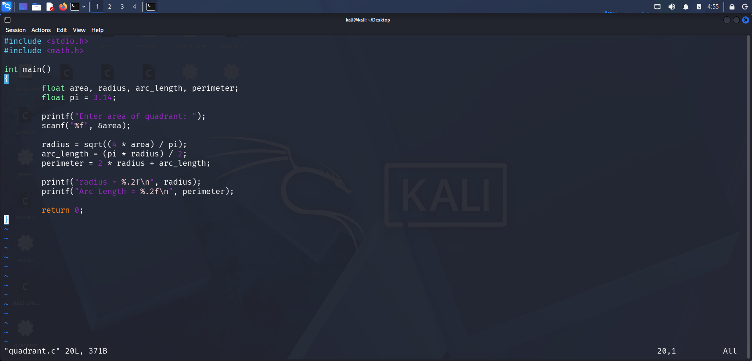


Question 2: Remaining Area of a Rectangular Sheet
Problem Statement:
Write a C program to find the remaining area of a rectangular sheet when a semicircular part is removed from it.
Input:
- Length of the rectangular sheet (L)
- Breadth of the rectangular sheet (B)
- Radius of the semicircular part (r)
Output:
Remaining area of the rectangular sheet
Formula:
Area of Rectangle = L × B
Area of Semicircle = (π × r × r) / 2
Remaining Area = Area of Rectangle − Area of Semicircle

Test case | Input | Expected output | Actual Output | Result (Pass/Fail)
1 | L = 10 cm, B = 8 cm, r = 4 cm | 54.87 cm² | 54.87 cm² | Pass
2 | L = 20 cm, B = 10 cm, r = 5 cm | 160.73 cm² | 160.73 cm² | Pass
3 | L = 15 cm, B = 12 cm, r = 6 cm | 123.45 cm² | 123.45 cm² | Pass

Algorithm:
- Start the program.
- Enter the length and breadth of the rectangular sheet.
- Enter the radius of the semicircular part.
- Calculate the area of the rectangle using Area = L × B.
- Calculate the area of the semicircle using Area = (π × r × r) / 2.
- Subtract the area of the semicircle from the area of the rectangle.
- Display the remaining area.
- Stop the program.

#include <stdio.h>

int main()
{
float length, breadth, radius;
float rectangle_area, semicircle_area, remaining_area;
float pi = 3.14159;

printf("Enter length of rectangular sheet: ");
scanf("%f", &length);

printf("Enter breadth of rectangular sheet: ");
scanf("%f", &breadth);

printf("Enter radius of semicircular part: ");
scanf("%f", &radius);

rectangle_area = length * breadth;
semicircle_area = (pi * radius * radius) / 2;
remaining_area = rectangle_area - semicircle_area;

printf("Remaining Area = %.2f cm^2\n", remaining_area);

return 0;
}
